Human Resource Management
Figure 9.1. Human resources management includes several duties, including hiring of new employees. [1]​

Learning Objectives & Introduction
After finishing this chapter, you will:
- Learn what human resources management is and how different components fit together to make an organization better.
- Understand what the different human resources activities are and how they are performed.
- Gain a better understanding of the recruiting and hiring processes.
- Understand the interview process and gain a better understanding of how different organizations may use different styles of interviews.
- Learn how human resources handles the different aspects of employee relations.
You have read about organizations establishing a competitive advantage through technology or organizational practices, but you might not have thought about how our employees can be the source of that competitive advantage. We know from the resource-based view of strategy, to gain a competitive advantage, companies must acquire resources that are valuable, rare, and that can’t be imitated. That describes each of you perfectly! Each employee is valuable and rare, and because we are all unique individuals, we cannot be perfectly imitated. So, if we can find them, great employees can be a significant advantage. It is our job as managers to help them be the best employee they are capable of being and keep them from wanting to leave.
Figure 9.2. Social capital is understanding the connections between employees and the organization to get the most out of them.​ [2]
Organizations are comprised of physical, financial, and human resources. The activities that center on the attraction, development, and retention of high-quality employees are referred to as human resource management (HRM).
Organizations that have good HRM policies and practices increase the production of their employees, as well as the value of their organization's services. This is known as human capital. In order to achieve and sustain competitive advantage, companies need to maximize this human capital by utilizing their resources in the best way possible. This connection between the individuals and how they fit within their organizations is known as social capital. It isn't enough simply to hire talented people. We need to make sure our policies, strategies, and relationships fit these people in a way they are able to get the most out of their potential.

9.2 Overview of HRM Practices
So how do we go about trying to accomplish these tasks? This figure provides an overview of the basic activities for human resource management, but it is important to notice that for each of these activities we must consider: do our actions fit within the overall strategy for our organization, are our activities legal, and are we engaging in ethical behavior.
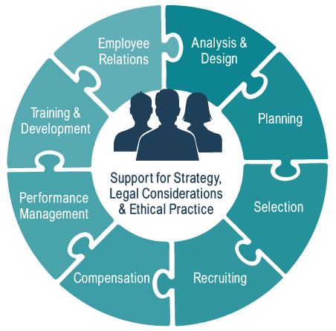Figure 9.3. An Overview of Basic Activities for HRM​​

9.2.1 Analysis & Design
​Companies and organizations structure themselves in a variety of ways for specific purposes, but the purpose of these various structures is to organize work so that the goals of the organization are accomplished. The tasks that are required to help the organization function are typically divided into multiple jobs so that the organization can function both effectively and efficiently without duplicated efforts.
A job is a collection of related tasks, duties, and responsibilities (TDRs). A position is the job held by an individual. For example, your instructor for a course may lecture, conduct quizzes, and grade papers (a job); their position within the university may be as an associate or assistant professor in a specific discipline.
A cornerstone of HRM is the process of understanding each of the jobs within the organization and ensuring that each job contributes to the overall mission, strategy, and goals of the organization. To do this, we conduct something called a job analysis. We may find that certain jobs are not contributing to the organization as they should, in which case we may need to change the TDRs for that job. This change is referred to as job design. To help you distinguish between these terms, you can think about it this way—job analysis helps us understand the job as it exists, while job design allows us to change the job as needed.
Figure 9.4. Every job is different with unique skills ​that may be needed. [3]
Job analysis may be conducted through direct observation of work, through interviews with current employees and managers, by examining similar jobs at other organizations, or by using resources such as O*Net OnLine, which contains detailed descriptions of thousands of different types of jobs. A good job analysis will use all of these methods to provide the most complete information possible. The result of the job analysis is a job description and job specification.
A job description is a summary of the tasks, duties, and responsibilities that are associated with a particular job. As a college student, your job description may include studying, attending classes, and rolling your eyes when a professor makes a bad joke. A job specification outlines the minimum qualifications that a potential employee must possess to be successful at that job in terms of the knowledge, skills, abilities, and other characteristics. So, again, as a student, the specification might include graduation of high school, a minimum GPA requirement, and the ability to find free t-shirts.

9.2.2 ​Planning
Once we understand the various jobs that are necessary within our organization, we then need to determine how many employees are required in each of those jobs. This process is called forecasting. What we really are doing here is educated guesswork. Think about the weatherman on your local news station. He is forecasting what he thinks the weather is going to be at a given time and place. He doesn’t know for sure, but he looks at patterns and data to make the best-educated guess. The only difference is in HR planning, you are dealing with jobs instead of weather.
The goal of this forecast is to determine whether we expect a labor surplus or labor shortage, and allow us to develop a strategy to deal with these possibilities. For those of you who plan on going into HR as a career, you will need to understand how statistical models work for forecasting and other predictive studies. If you are interested in some of these intricacies, check out this site. However, for our purposes, we are going to keep it at the surface level.
Figure 9.5. Forecasting: How many employees does it take…?​
What everyone needs to understand is that it is very rare that we have the perfect number of employees to meet our strategies. The knee-jerk reaction to shortages or surpluses is to simply hire or fire employees as needed, but these reactions can be damaging to an organization’s reputation and bottom-line.
To deal with a labor shortage, we might have our existing employees work overtime. We could bring in employees from a staffing agency, contractors, or other temporary help. If we expect to need these employees for the foreseeable future, then we might go ahead and hire them on as full-time employees. The point is that the correct strategy might not simply be to hire new employees. We should consider carefully whether we need a permanent or temporary solution.
Similar considerations have to be made when determining what to do about a labor surplus. You might think that laying off all of my extra workers is the most expedient solution, but consider all of the potential negative outcomes that accompany such a move. The organization now pays higher unemployment insurance, workers don’t feel valued, negative publicity, and other potentially undesirable consequences. Instead, the company might consider temporary furloughs, reducing hours, early retirements, or other strategies to reduce labor hours while not going to the extreme of layoffs or downsizing.

9.2.3 Recruiting
If your organization has determined that it has a labor shortage and needs to bring in new talent, then the first step is recruiting. Recruiting can be done internally or externally and using a variety of methods and sources.
- Internal recruiting means using existing employees to fill vacancies within the organization. There are a number of benefits to internal recruiting which include: knowledge of the employee’s current performance, enhanced loyalty from the opportunity to advance from within, lower cost, less time consuming, and consistency in the workplace. However, there are also a number of drawbacks. These might include: creating another opening by moving people around, limiting your pool of options, and not gaining a unique perspective someone from outside the organization could offer.
- External recruiting is the process of finding and attracting potential employees from outside the organization. The advantages and disadvantages are essentially the reverse of the internal method. It is more expensive and time-consuming, but offers the opportunity to bring in new talent, ideas, and perspectives.
​External recruiting can be done in a variety of ways. The most cost-effective and most successful is generally through employee referral.This means that the organization uses existing employees to find new employees through those individuals’ social networks. Other companies might attend career fairs at colleges or universities. Most organizations will use their websites or an online presence to “spread the word.” Some companies might even advertise on radio or television.
​Which of these methods is the best? Well, it depends. Who are you trying to recruit, and where are they likely to see your message? Based on your job analysis, you should understand the type of individual you are trying to recruit, then tailor your message and recruiting methods to locate those individuals.

9.2.4 Selection
Once we have developed a pool of interested individuals through our recruiting efforts, we need to figure out which of them would be the best employee. We will examine the selection process by dividing it into four assessment methods: initial, substantive, discretionary, and contingent. During this process, we refer to individuals under consideration as applicants, candidates, finalists, and new hires depending on how far they make it during the process.
The initial selection methods are when we determine whether or not each of our applicants meets the basic minimum requirements for the job. Applicants submit resumes or complete applications that highlight their education, experience, and other pertinent information. Companies are trending toward putting more focus on applications rather than resumes. The reason for this is that recent research has found that approximately 75% of people exaggerate their education and experience, while around 50% will outright lie on their resumes.¹ Most applications include a signature requirement and disclaimer that states you may be terminated if it is discovered you lied or dissembled on the application. This same guarantee does not exist on the resume.

Liar, Liar. Pants on fire.​
​If an applicant is deemed to meet the minimum qualifications, then they become a candidate for the job. This begins our substantive assessment methods in the selection process. Candidates are subjected to a number of selection methods in an attempt to rank order or distinguish them from all of the other candidates. These methods could include personality assessments, cognitive ability testing, job knowledge tests, physical ability tests, or samples of previous work. The substantive stage is also when most organizations will conduct the most in-depth interviews. The Society for Industrial and Organizational Psychology has a list of various substantive assessment methods as well as a discussion of the advantages and disadvantages of each.
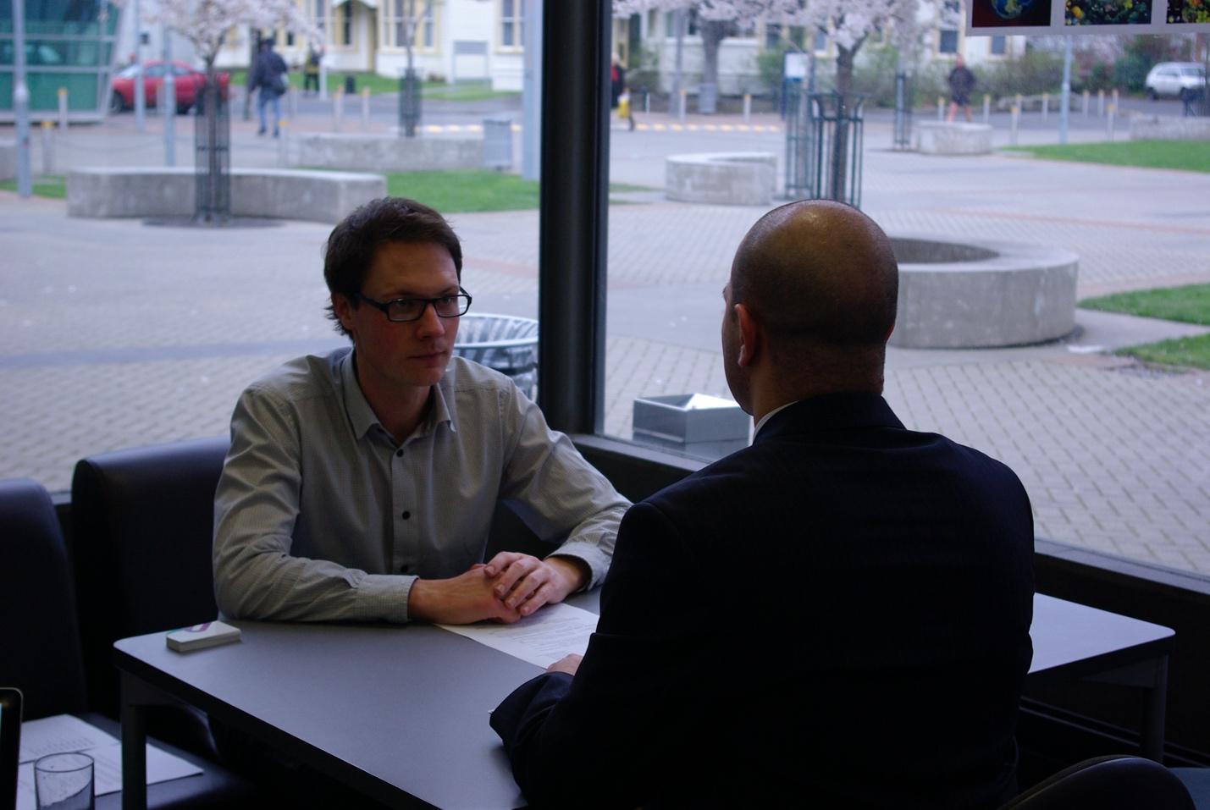​Figure 9.6. Interviews are a part of the substantive stage of selection. [4]​
​Interviews typically take one of two forms. The superior approach would be to conduct a structured interview. Structured interviews use a predetermined list of questions that are asked of each candidate and will often be evaluated using a standardized scoring system. This means that every candidate is asked the same questions, and the quality of their responses can be easily compared. Structured interviews are also typically comprised of behavioral and situational questions. Situational interview questions consist of hypothetical situations. “What would you do if your manager asked you to something illegal?” This is meant to get an idea of a candidate’s future behavior. Behavioral interview questions ask about a candidate’s past experiences. “Tell me about a time that you failed, and how did you overcome that failure?” So while situational questions examine potential future behavior, behavioral questions look for critical incidents in the candidate’s past.
Unstructured interviews are essentially conversations between the hiring manager and the candidate. There is no list of questions or systematic scoring system involved. Unstructured interviews are considered highly suspect because of their risk for bias and are often attacked in legal proceedings for just that reason.
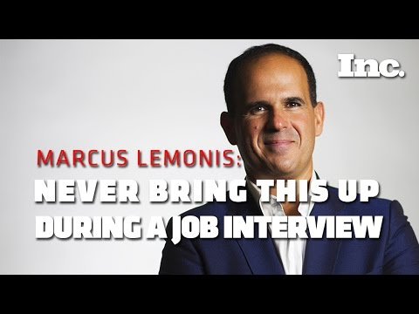
You have to understand what you are and are not looking for from interviews.​
Once all of the appropriate substantive assessments have been conducted, this should allow us to develop a list of the job finalists. These finalists move on to the discretionary assessments in our selection process. If there is a single finalist, then hire the person, pass Go, and collect $200. However, if you have multiple finalists that you feel are equally qualified for the job, you need a method to further distinguish among these individuals. At this point, some organizations that have an active interest in promoting diversity in the workplace may use demographic characteristics to promote underrepresented groups. Other organizations may use evaluations based on the finalists fit with the organization as a whole, not just with the job. They might determine which finalist best matches the culture of the organization.
At this point, we are ready to make our offer of employment. We refer to the individual as a new hire, but there is still one final set of assessments. These assessments are called contingent because employment is contingent upon the successful completion of these last steps. Some companies may require drug testing. Others may run a final background check just to make sure you are who you say you are and haven’t done anything bad enough to warrant you un-hirable. This is also the point at which many organizations will contact the references that you provide.

9.2.5 Training and Development
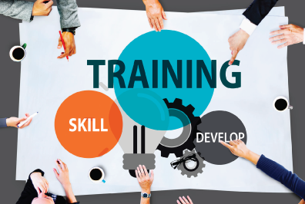Figure 9.7. Training and development are key to making sure your employees are successful.​​
​Regardless of how qualified or experienced a new employee might be, they will still require some degree of training. Training is an organization’s efforts to give employees the knowledge or skills to better do their current job. We differentiate this from development, which is meant to improve an employee’s knowledge and skills for jobs they might hold in the future. In other words, we train you for now and develop you for later.
Training is typically conducted either on- or off-the-job. On-the-job training takes place while the employee is engaged in the tasks, duties, and responsibilities of the job itself. Off-the-job training takes place in a lower-stakes environment that might involve a classroom or online training. Regardless of whether the training is on- or off-the-job, HRM professionals spend significant resources determining the best methods and strategies for teaching new employees the skills they will need to be successful while watching budgetary restrictions.

This is how some online training may be done.​

​9.2.6 Performance Management
Once we have hired, trained, and paid our employees, we need to ensure that they are in fact doing their jobs well! Performance management is how organizations make sure employees are doing what is needed and working toward organizational goals. Performance management is often based on performance appraisals constructed by managers or supervisors. These can be either objective or subjective and utilize a number of criteria.
Objective appraisals, also called results-based appraisals, are based on some kind of objective or numeric outcome. How many units were produced? How many cars sold last month? What percentage of customers were contacted within two hours? Each of these has a specific value that can be assessed and compared to established goals. The benefit of these types of appraisals is that they are legally defensible and they measure some tangible output. The problem is that in today’s economy, many jobs do not have a single tangible output on which we can base a performance appraisal.
Figure 9.8. Objective appraisals are based on measurable metrics.​ [5]
This lack of a tangible output may encourage an organization to utilize a subjective appraisal. Subjective appraisals, rather than being based on a specific measure, are instead rooted in the perception of the manager or supervisor doing the appraisal. Behavioral appraisals are a form of subjective appraisals that evaluate specific behaviors in the workplace such as “arrives on time,” “greets customers with a smile,” or “contributes to employee meetings.” While there is still room for subjectivity in the evaluation of these behaviors, methods such as behaviorally anchored rating scales (BARS) can remove some bias and create more objective standards for appraisal.
Regardless of how performance appraisals are constructed and performed, there is a growing backlash against the entire process. UCLA’s Dr. Sam Culbert has written extensively on the dangers of this process and was recently the author of an article on the topic in the Wall Street Journal. You can read Dr. Culbert’s article here, and listen to a conversation on the topic that aired on National Public Radio.
While Dr. Culbert’s arguments are well reasoned and have support, it is important to understand why performance appraisals continue in most organizations. Performance appraisals serve three primary purposes:
- Strategic – Appraisals help align the work of individuals with that of the organization as a whole.
- Administrative –They provide us information on who our best and worst employees are and who should receive bonuses, promotions, or should be targeted for termination.
- Developmental – Performance evaluations help us identify high-potential employees that would benefit from development opportunities and also helps us identify low-performers that are in need of supplemental training or support.
Finally, performance management systems should provide specific feedback to employees to let them know what they are doing well and where they need to improve.

9.2.7 Separation from the Organization
Another aspect that goes hand-in-hand with performance management is turnover. Employees typically don’t stay with a single organization for their entire career. In fact, according to a Bureau of Labor Statistics study, the average American worker has had nearly 12 jobs by the time they are 48 years old!² People leave their jobs, and for several reasons. However, organizations that can manage turnover rate and understand why employees are leaving, will have a big advantage.
Figure 9.9. Layoffs are one method of turnover​. [6]
Turnover can be either voluntary or involuntary. Involuntary turnover refers to employees that are fired or laid-off. This may be for violations of company policy or poor performance in the case of firing, or due to downturns in business or the economy in the case of layoffs (also called downsizing). Voluntary turnover refers to employees that leave the organization for their own reasons. What we need to do is figure out whether the reason they left was avoidable or not.
Unavoidable voluntary turnover is when an employee leaves, but not due to the organization. If an employee has a sick family member and has to move to a certain city to be closer to better hospitals and treatment, there is very little that can be done to hold on to that employee. We wish them well and begin looking for a replacement. Avoidable voluntary turnover, however, represents those employees that leave the organization for better opportunities, better pay, better management, or for any other cause over which we have direct control. When we experience high avoidable voluntary turnover, we need to understand that this is a symptom of something wrong within our organization.
Exit interviews are one way of trying to diagnose what type of turnover is occurring. The purpose of these conversations is to determine why they are leaving and what we can do in the future to improve the conditions and environment for our other employees.
While separations from the organization might be inevitable, they are also very expensive and organizations spend significant resources on strategies to minimize turnover.

9.2.8 Compensation
Once an employee has been hired, they probably want to be compensated for their labor. We can think about compensation as everything the organization provides for an employee doing their job. We can break down these rewards into three separate categories: base pay, incentives, and benefits.
Figure 9.10. Compensation is everything, including money, that an organization provides for an employee doing their job.​ [7]
Base pay is the starting point for compensation. It is basically the salary that an employee receives for doing their job. Base pay will fluctuate with factors such as rarity of the skills involved, availability of other workers, and the amount of danger or risk associated with the job.
In some jobs, competition for talented employees is so fierce that organizations are forced to offer incentives. Incentives are compensation above and beyond just the base pay and may include bonuses, stock grants or options, profit-sharing, or other programs. These incentives are typically done as a percentage of base pay. It is important to understand this for salary negotiation purposes. A lot of companies may offer a lower base pay, but have many incentive programs to bring total compensation up. Make sure you know what you are earning and which is more beneficial to you.
Finally, under federal law, all employers are required to offer some benefits to their employees. These required benefits include Social Security and Federal Insurance Contributions (FICA) among others. Most organizations realize that they must also include other benefits to be competitive in the labor market. These optional benefits include things such as health insurance, vision and dental insurance, paid time off, retirement savings accounts, and educational reimbursement. The Bureau of Labor Statistics recently reported that benefits comprise approximately 30% of an employee’s total compensation package from their employer.³

9.2.9 Legal Aspects of Human Resource Management
As we discussed at the beginning of this chapter, there are legal considerations that underlie every aspect of human resource management. How we treat our employees is largely impacted by acts and laws that have been passed over the years. The timeline below will give you some specifics for each of the laws that the HR manager needs to understand and abide by to have positive employee relations.

Steeping some tea...
​There are four categories that we are concerned with when it comes to treating our employees fairly and correctly. Those categories are labor relations, compensation and benefits, health and safety, and equal employment opportunity.
Labor Relations
When it comes to labor relations, the majority of Federal legal issues surround unionization. However, union membership has fallen in recent years, from 20.1% in 1983 to 10.7% nationwide in 2016 according to the Bureau of Labor Statistics. In the table below you can see the current (2016) percentages of workers that belong to unions in the states in our region of the United States.
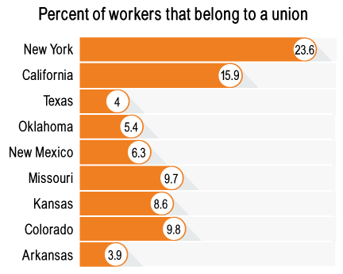​Figure 9.11. Bureau of Labor Statistics, 2016 ​
​While the number of employees “represented” by unions is still significant, it is easy to see the decline in union membership over time. The reason for this decline can be debated, but due to the small percentages of workers impacted by these laws, we will forgo any further discussion. Bottom line: know if unions are important in your industry and location.
Compensation and Benefits
The Social Security Act (SSA) was the first of the major laws pertaining to compensation passed by the U.S. government. The SSA established the first U.S. retirement fund and, nearly 80 years later, maintained its importance and has been the subject of several recent political debates. Then, in 1938, the Fair Labor Standards Act (FLSA) was passed. Other laws such as the Affordable Care Act (2010) are currently still mandated by the government, so HRM professionals must stay informed as to what pay and benefits are required under local, state, and federal laws.
Health and Safety
U.S. law dictates that workers are entitled to a safe and hazard free environment in which to work. The Occupational Safety and Health Act (OSHA) and supplemental legislation is the main directive, instructing companies to act in their employees’ best interests in matters of workplace health and safety.
Equal Employment Opportunity
Figure 9.12. Prohibiting discrimination is a large part of an HR director's duties. [8]​
The final category of laws that are important for HRM professionals are those that cover Equal Employment Opportunity (EEO) in the workplace. These laws primarily address discrimination in the workplace based on several demographic categories. Workplace discrimination happens when employment decisions (hiring, promotion, performance appraisal, etc.) are made based upon factors that are not relevant to the job. Essentially, all EEO legislation states that employment decisions must be made based on job-related criteria.
There are two types of workplace discrimination we need to be concerned with. The first type is called disparate treatment, which is intentional discrimination based on an individual’s belonging to a protected category such as race, gender, or disability. While we often think of discrimination in the worst of ways, disparate treatment is something that can even come from some of the best intentions.
Suppose Tom is in the position of International Accounts Manager, a job that requires considerable travel. Tom unfortunately suffered a serious car accident that required his left leg to be amputated, leaving him disabled and making it much more difficult to get around. Tom’s company, trying to make his job easier, decides they are going to take away the travel from just his position. Sally, who has the same job title, still has the travel schedule Tom used to have prior to the accident. The company is intentionally treating Tom differently because of his disability. Even though the intent is meant to be beneficial to Tom, he may not have wanted the change. Tom just wanted to go back to his normal life, but he isn’t able to because of the change. As managers, you need to be careful of situations where people are treated differently. Even the best of intentions can have negative consequences.
Adverse impact is the other type of discrimination. This occurs when an employer uses some criteria for making employment decisions that while not overtly discriminatory, still has a discriminatory impact. For example, if I was the proprietor of a restaurant and required all of my kitchen staff to be over six feet in height, I would disproportionately hire men over women. This would be classified as adverse impact in this case since height has nothing to do with someone’s performance when it comes to preparing food.

Workplace discrimination example
​Many of us look at these examples and think, “this doesn’t happen nearly as much as it used to.” However, in 2016, the Equal Employment Opportunity Commission (EEOC) handled more than 91,000 individual complaints, with racial complaints (35.3%) and disability (30.7%) being two of the top three complaints.⁴ This was an increase of more than 10,000 cases from 20 years prior.
Because of this history of workplace discrimination, companies that have contracts with the government are required to engage in affirmative action. Affirmative action is an effort to achieve an equitable environment for all employees. Affirmative action programs are not quotas! Quota systems are illegal except in the case of egregious action on the part of specific employers. Instead, affirmative action programs attempt to provide a level playing field on which decisions are made only considering job-related criteria.
Along with workplace discrimination and affirmative action, EEO laws also cover sexual harassment under Title VII of the Civil Rights Act. There are two types of sexual harassment that violate the law—quid pro quo and hostile work environment.
Quid pro quo literally means “this for that.” In regards to harassment, it is the granting of a job benefit based on acceptance of a sexual demand. Hostile work environment occurs when office behavior creates an environment that is difficult or uncomfortable to work in. Quid pro quo is the type of discrimination that is dramatized in many movies and shows, but hostile work environment is the far more common type of harassment.

Sexual harassment in
the workplace. ​
​The final takeaway we want you to have from this section is to be wary of what you are doing, how you are doing it, and who you are doing it with and around. Something that one person may not see as being offensive, discriminatory, or unfair may not be seen the same way by another person.

9.3 References
1. R. Strauss, “When the Resume Is Not to Be Believed,” New York Times, Sept. 12, 2006, p. 2.
2. Number of jobs held, labor market activity, and earnings growth among the youngest baby boomers: results from a longitudinal survey. (2008). Washington DC: U.S. Dept. of Labor, U.S. Bureau of Labor Statistics.
3. Latest Benefits News Release. (n.d.). Retrieved June 17, 2017, from https://www.bls.gov/ncs/ebs/#data
4. Charge Statistics (Charges filed with EEOC) FY 1997 Through FY 2016. (n.d.). Retrieved June 16, 2017, from https://www.eeoc.gov/eeoc/statistics/enforcement/charges.cfm

9.4 Answers to Discussion Questions

Answer to Question 9.15
How do you feel about the practice of conducting background checks?
- Answers will vary, but the logic should be that background checks are important to protect employers and their customers from potential employees that pose a risk in the workplace based on their previous behavior. From the potential employee’s perspective, background checks should only be conducted and use information that is directly related to the position (tasks, duties, and responsibilities) for which they are applying. Minor offenses or offenses that are unrelated to performance of the job should not be considered in the hiring decision.
When should background checks take place in the hiring process?
- The facts from the Target case in the article indicate that background checks should be conducted during contingent assessment rather than early in the process. This allows employers to base their hiring decisions on relevant factors during the initial and substantive assessment stages.
Click here to return to Question 9.15.

9.5 Image Credits
[1] Image courtesy of Tim Gouw in the Public Domain
[2] Image courtesy of Rob Dye in the Public Domain
[3] Image courtesy of Igor Ovsyannykov in the Public Domain
[4] Image courtesy of Samuel Mann under CC BY 2.0.
[5] Image courtesy of Goumbik under CC0 Public Domain
[6] Image courtesy of geralt under CC0 Public Domain
[7] Image courtesy of Sharon McCutcheon in the Public Domain
[8] Image courtesy of Alexas_Fotos under CC0 Public Domain

Leadership Theories and Trends

Learning Objectives & Introduction
After finishing this chapter, you will:
- Gain an understanding of what the difference is between a manager and a leader.
- Learn the different types of power and how they may be used to influence others.
- Learn the different historical theories of leadership and understand how these models have progressed over time.
- Understand how important flexibility of style for leaders is when it comes to leading several employees.
- Learn some contemporary trends in leadership and get an idea of how these trends may be used in organizations moving forward.
This is a management course, so understand that what is stated next doesn’t sound like something that you should read here.
You don’t want to be a manager.
Crazy, right? The idea behind that statement is that you want to be more than just a manager. What you really want to be is a leader. Your goal, if you become a manager at some point, should be to break the mold and take it to the next level. Leadership is that next stage in evolution for successful managers.
This is a textbook, so we have included a definition for leadership. However, what you need to realize is that leadership can mean something different to every person and in every organization.
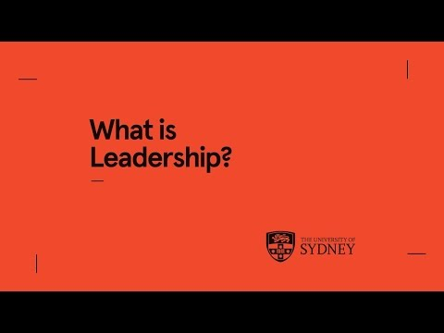
What is leadership?​
While people may not agree on exactly what leadership is, it has become increasingly clear what leadership is not. In the past, many people used the terms leadership and management interchangeably. This is not the case anymore. There are distinct differences between leaders and managers.
Managers focus on work and tasks. Some of the activities associated with management are:
- Planning
- Budgeting
- Organizing
- Controlling
- Coordinating
These are all necessary aspects of making sure an organization is running smoothly. However, it’s what these activities don’t include that sets leaders apart. Leadership activities include:
- Coaching
- Teaching
- Mentoring
- Inspiring
- Empowering
A leader is someone who is able to harness relationships and motivate people to push harder and go farther than they normally would. One other item to note about this difference is that with each of these activities, it isn’t necessary to be in a managerial role. Leadership can be shown from any level of employment. What is typically found along with leadership, though, is power.

8.2 Power and Influence
When discussing power, much of what we think of comes with a level of authority. This is true for a few of the sources of power, but not all. It is important to understand the different types of power people can have.
Presidents of the United States have legitimate power based on their position.
Legitimate power – Legitimate power is the concept we are likely most familiar with. This power is derived from someone’s rank within an organization. The higher someone is in the organization, the more legitimate power that person will have. We see this power come into play on a daily basis—such as when parents tell their kids to do their chores or executives have their assistants complete various tasks. Bottom line: legitimate power is authority.
Reward power– This power comes from the ability of a person to give rewards. Since rewards typically center on money, bonuses, and other compensation, it is natural to think that people with reward power are in positions of authority. However, this isn’t always the case. There are several rewards that don’t require formal authority to be disbursed. Praise and recognition are common rewards that a lot of employees greatly value. These are examples of rewards that could be given by anyone at any level. The leaders who are successful using reward power are usually the ones who have grown to understand which rewards are valued by each individual.
Coercive power – Coercive power is the type of power that comes from punishment, or at least the ability to threaten punishment, of another person. Some examples of coercive power in organizations are demotion, suspension, and termination. Managers will use this power to make sure deadlines are attained and to ensure employees comply with rules. This form of power also has the highest likelihood of being abused. If this power is not used correctly, or is used too often, there is a risk of being seen as a bully or possibly creating a hostile work environment. Coercive power can be effective, but it also needs to be used in moderation to avoid issues.
Figure 8.4. ​Aaron Rodgers, quarterback for the Green Bay Packers. [4]
Expert power – Expert power comes from having special expertise or skill in a given area. This set of skills or knowledge allows for someone to be needed and valued when it comes to their subject of expertise. The fewer people there are that have a particular skill, the greater the amount of power that person will have. For example, look at quarterbacks in the National Football League. The fact that these men are arguably the 32 best quarterbacks in the world affords them the power to demand higher salaries (averaging around $16.5 million in 2016) and more privilege with their teams. Compare this to the nearly 3.5 million U.S. public school teachers, who make just a little bit less than the average quarterback per year.
Referent power – Referent power comes primarily from admiration and identification. This is the most abstract of the different forms of power. This power is really dependent on how the leader is perceived by his or her followers. One of the drivers for this power is charisma. It isn’t a measurable data point, but instead simply the leader’s personality or attitude that draws in followers. We see celebrities in movies and advertisements for this very reason. People want to be associated with them because they are identifiable or because of what they represent.
Each of these different forms of power gives leaders the ability to do the one thing that all leaders need to do: influence their surroundings. The ability to use influence is what helps distinguish who our leaders are. And just as we discussed with power, influence can come from any level. Think about your lives and who has influenced your school career or upbringing. For the majority of you, it was likely friends or peers that got you involved in a sport or club; or a coach or teacher that helped or explained something in a different way. These people that can influence others in a positive manner are game-changers.

8.3 Leadership Theories
There are a number of different theories related to leadership. Theories on what it takes to be a good leader. Theories on how to adapt as a leader. Theories on how leaders should act. The list goes on and on. What we will attempt to do in this section is to go through some of the more well-known theories, explain them, and put them into context so you can understand how they affect today's leaders and organizations.

8.3.1 Trait Theory of Leadership
The trait theory of leadership is typically the first theory that scholars tend to discuss. It is fairly simple in how it is constructed. Dating back to the mid-1800s, Thomas Carlyle proposed something called the “great man” leadership theory. In looking at the leaders up to that point, he suggested that leaders had innate traits that made them great, hence the phrase “great leaders are born, not made.” According to these early theories, men with traits such as above-average height, attractiveness, and assertiveness would magically be good leaders simply by showing up.
As time, and conventional wisdom, moved on, people began to realize that just having these traits weren’t enough. Ralph Stogdill conducted studies in the mid-1900s, finding that social situation and situational context also played a part. What this means is that some of these traits do matter, but it is what you do with these traits more so than just having them. People who possess some of the traits associated with successful leadership can be more effective in a given situation than those who do not—if the traits are used effectively.
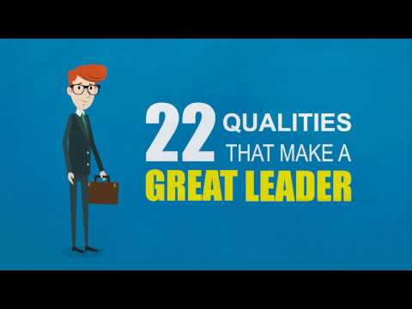
Some of the traits that help make great leaders​
While most of trait theory is focused on the positives, the “dark side” traits of leaders also need to be discussed. These traits, which are inherently not good, are also what likely got some leaders into the positions they are in today.
- Narcissism – Arrogant, entitled, and hostile are ways to describe this type of person. We often think of our leaders as confident and assertive. But when taken too far, it crosses over into dark territory. Employees dislike people who make decisions based on how they will affect their own reputations instead of being good for the overall group. This type of leadership typically results in lower job performance and fewer organizational citizenship behaviors among employees.¹
- Machiavellianism – This trait is characterized by the ability to use any means necessary to get what they want. Coined after a 16th-century book, the themes and lessons are still very relevant. Machiavelli wrote that leaders are politically oriented and should lie, manipulate, and forcibly do what is necessary to gain power. Then, once power is obtained, do what is needed to maintain authority. Obviously, these methods are unsavory and should be left out of your business dealings.

Are dark side traits all bad?​

8.3.2 Behavioral Theories
As people began to realize that traits weren’t the only thing that mattered when it came to leadership, they began to look at other aspects of human nature. A manager’s actions seemed like the next logical step, so they began to look at how successful leaders behaved differently than those who struggled. This brought about the next round of leadership theories—behavioral theories. When discussing behavioral theories, there are two basic concepts that drive the majority of thought behind these theories—task orientation and relationship orientation.
If you are familiar with collegiate sports rivalries at all, then the dispute between who actually came up with the idea of leadership behaviors will make a lot of sense to you. In the 1940s, both the University of Michigan and Ohio State University came up with very similar ideas for how leaders’ behavior affects employees. Depending on who you ask, they will tell you that their school came up with the idea first. But nonetheless, the theory was created.
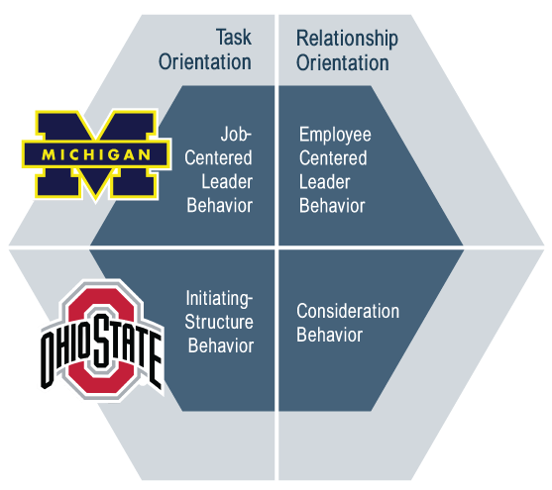Figure 8.6. Behavioral Theories​.​
The Michigan study came up with its concepts related to this paradigm: job-centered leader behavior (task) and employee-centered leader behavior (relationship). Job-centered behaviors are focused on the processes and making sure the tasks were getting completed properly. Employee-centered behaviors are focused on job satisfaction and the overall welfare of the employees. This theory stated that the leader behavior would favor one set of behaviors over the other and that the leader’s actions would fall somewhere on the continuum between these two apparent opposite behaviors.
The Ohio State study looked at things slightly differently than their rival. Their study looked at these different behaviors and said that they didn’t have to be opposites, but instead could be looked at independently of each other. This meant that a leader’s behavior could be both task- and relationship-oriented at the same time, or as they called them: initiating structure behaviors (task) and consideration behaviors (relationship). Initiating structure behaviors were those actions that clarified the structure of the organization or tasks. Consideration behaviors were those actions that helped establish support among the employees and a friendly environment.
Regardless of which one came first, they both showed that there are different types of actions a leader can utilize to accomplish different things within an organization. It was no longer just the traits that made a difference, but also the actions that dictated how successful a leader could be.

8.3.3 Situational and Contingency Theories
The next set of theories take yet another step forward. These theories demonstrate that there should be more involved than just the leader’s traits and behavior. They begin to take into account that life happens in more than just one ideal way. Context actually matters. Crazy, right?
Contingency Theory
We’ll start with Fred Fiedler’s contingency theory because it plays directly off of the behavioral concepts we just discussed. Contingency theory looks at a leader’s behavior and determines if a leader’s style is task oriented or relationship-oriented and if that style is effective for the situation at hand. This theory was the first to look past just what the leader’s style is, but then add the concept of situational control in the work environment.
Situational control is broken down into three variables present in the leader’s immediate environment. From least important to most, the variables are:
- Position power – How much formal authority does the leader have?
- Task structure – Are the employees’ tasks routine and well-structured, or are they flexible and ambiguous?
- Leader-Member relations – What is the relationship between the leader and the followers?
Leader-member relations is the lynchpin in this theory. The relationship dynamics between a leader and his or her followers will dictate more than anything how successful a leader can be in a given environment. The really interesting part of this theory is how leader-member relations are determined.
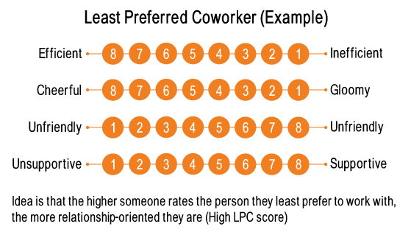Figure 8.7. LPC Example​.​
Think of the person in your office that you would least like to work with. Then answer a questionnaire based on your thoughts toward that person. This is a test known as the Least Preferred Co-worker (LPC) assessment. While it may initially sound kind of backwards, it actually makes a lot of sense. The thought behind this is the higher you score someone who you don’t want to work with, the more it shows that you truly care about relationships. If your score is higher, you would be seen as a relationship-oriented leader. If your score is lower, you are task-oriented.
Figure 8.8 shows how the different variables interact to show which leadership style would be best for each given situation. This means that if a leader is task-oriented, the best situations are those that are either high or low control. Relationship-oriented leadership typically works better in moderate control environments. This theory is also different from other theories in this category in that Fiedler believed leadership style is not very flexible. So if a leader is task-oriented, it would be very tough for that person to adapt to a situation that requires a relationship-oriented style.
Path-Goal Theory
Path-goal theory is the next theory and is usually a little easier to understand than contingency theory. This is one of the first theories to link motivation and leadership styles. Path-goal is related to expectancy theory, which we went over in the motivation chapter. The whole idea behind this theory is for the leader to determine the style of leadership that would be best suited to help employees get what they want based on the situation and the type of employee they are leading.
Figure 8.9. Someone using the Path-Goal Leadership model would understand that not all employees respond well to direct, authoritative leaders.​ [6]​
There are four styles of leadership associated with this theory, breaking through the more simple task and relationship styles we have discussed.
- Directive– The leader is direct and authoritative with employees.
- Achievement-oriented – The leader shows confidence in employees and challenges them to show confidence in their task efficacy.
- Participative– The leader takes a hands-on, peer-based approach.
- Supportive– The leader is caring and nurturing toward the employees’ needs and well-being.
This theory states that leaders can be more flexible with their styles, unlike what Fiedler theorized. So, for example, a leader may have a less experienced employee and realize they don’t know as much as some of the more tenured employees. This leader would likely implement a more directive style to get the results they are looking for. If the employee is more seasoned, the leader may use a more achievement-oriented style. The point is that leaders are expected to individualize their leadership based on the employee and the context.
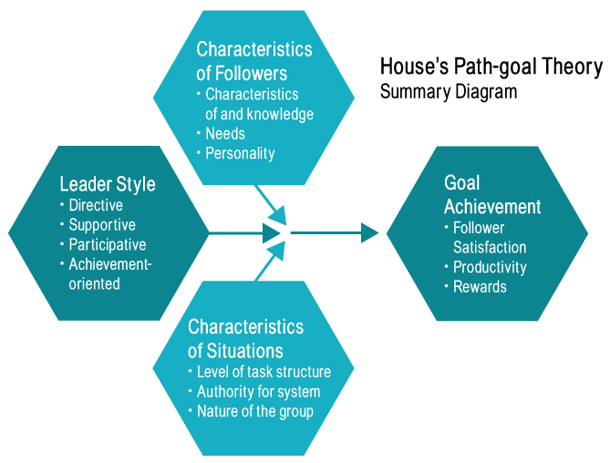Figure 8.10. Path-Goal Theory Model​.​
Situational Leadership Model
The last of the theories for this section is the first to account for the readiness level of the followers. The situational leadership model takes followers and puts them into four different categories of readiness based on how they equate to two variables—task ability and motivation. Task ability refers to the skill level of the follower. If an employee is new and limited in their experience, they would be low on this scale. Motivation looks at the desire a follower has to complete the tasks.
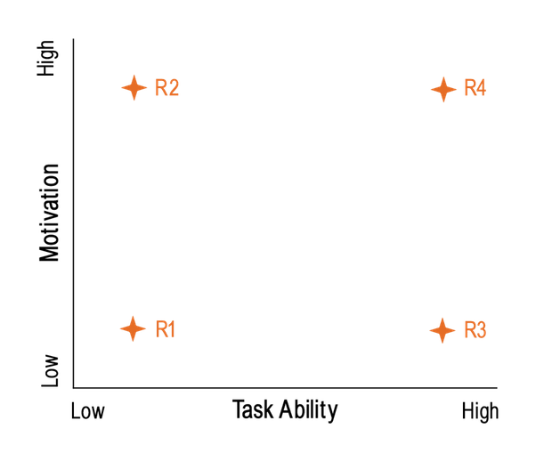Figure 8.11. Follower Readiness Level Grid.​​
Along with this, we also need to look at the leadership styles. Similar to path-goal theory, there are four different styles leaders may implement.
- Telling – Leaders are specific and direct, telling followers instructions.
- Selling – Leaders give guidance, but there is discussion and give-and-take from the follower.
- Participating – Leaders work alongside the followers, placing emphasis on relationships and collaboration.
- Delegating – Followers are given more responsibility and autonomy to get tasks completed with minimal oversight.
Based on the readiness level of the follower, different leadership styles are going to be more effective.
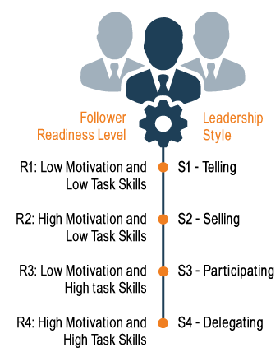Figure 8.12. Leadership styles based on follower readiness.​​
This theory gets into the evolution of the employees based on the tasks they are completing. If employee X has been doing a specific (and slightly boring) task for 3 years, he may be sitting in R3 on the readiness grid. So we would likely be successful using a participating style. However, if that same employee has been doing a more enjoyable task for that same amount of time, he would be considered an R4. We would probably do more delegating and let him do his own thing. Suppose that same employee tries a new task that he is somewhat unsure of, his motivation and skill level may not be as high as when he is doing the other tasks. This would put him in R1. We would employ more of a telling style for this task.²
We need to make sure we are understanding how the situation dictates how we should lead our followers.

8.3.4 Contemporary Theories
There are some other theories that aren’t as steeped in research and that are still being discovered and tested. Like everything else we do in business, we need to make sure we are constantly looking to better how we run our organizations, and leadership is no different.
The most well-known of these burgeoning theories is the transformational model of leadership. This model looks at leadership as a method for bringing about change. The idea is to transform the way people work within an organization. Leaders that have been shown to be transformational have done so by utilizing four components, referred to as the 4 I’s:³
- Idealized influence – The leader is the ideal role model and is admired for “walking the talk.”·
- Inspirational motivation – These leaders have the ability to inspire and motivate followers.
- Individualized consideration – Leaders are concerned for the well-being of followers, committing personal attention to each follower.
- Intellectual stimulation – The leader stimulates followers by challenging them to think differently and be creative.
Transformational leaders are most often characterized as being charismatic. They are good at providing the spark, or pushing followers to higher levels. One downfall of the transformational leader is the ability to keep things running. Much like fireworks, there is amazement and an explosion at first, but that only lasts so long.
Figure 8.13. Transformational leadership – exciting and inspiring, but doesn’t always last long.​ [7]
Another contemporary model that has ties to situational theories is Leader-Member Exchange (LMX). Think about your school career. Did you have professors that you got along with better than others? Maybe this was due to age differences, personal characteristics, or maybe even because you liked the same sports team. LMX looks at the relationships between leaders and followers and accounts for the realization that every person is different and each relationship has different dynamics. If each relationship is different, then each person is treated in a different manner
This theory has ties to social categorization, which we discussed in Chapter 3. The members who have a high-quality relationship with the leader are the in-group members. They are typically given more responsibility and better access to resources. Those members with lower quality relationships don’t have the same influence or support of the leader. These members are seen as the out-group.
Just as it appears, this model shows that there can be politics that are present in organizations. Understanding where you stand in your relationships is important for job satisfaction. The better you enhance the leader-member relationship, the more likely you will find yourself a part of the in-group.

8.4 Emerging Thoughts on Leadership

8.4.1 Diversity of Leadership
When discussing leadership, we need to understand that as times change, so do the ideas of what characteristics are needed to be successful as a leader. Diversity in society and organizations has increased exponentially over the years. Studies show that companies with gender-diverse leadership are 15 percent more likely to outperform their industry medians. Ethnically diverse companies are 35 percent more likely.⁴ With these changes, we need to be wary of how to adjust to keep up with the different kinds of people they are leading and who the next leaders will be. Despite knowing that diversity of leadership is a positive addition to organizations, there are still glaring shortcomings when it comes to leadership. Among Fortune 500 companies, only five have African American CEOs, and there are actually fewer female CEOs (4.1%) than CEOs named David (4.5%) or John (5.3%).⁵ The glass ceiling is still very much present in today’s society.

Despite knowing that diversity of leadership is a positive addition to organizations, there are still glaring shortcomings when it comes to leadership. Among Fortune 500 companies, only five have African American CEOs, and there are actually fewer female CEOs (4.1%) than CEOs named David (4.5%) or John (5.3%). The glass ceiling is still very much present in today’s society."
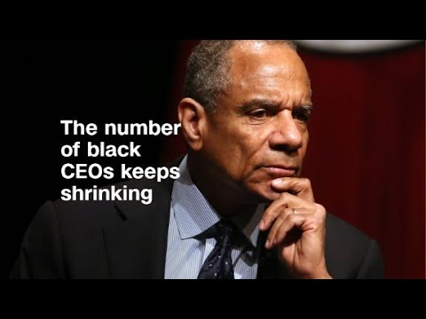
The number of black CEO's keeps shrinking​

8.4.2 Political Behavior
Figure 8.15. Diversity remains an issue among leadership. [9]​​​
Political motives are present in all organizations and among all leaders. With networking being the major method that most people obtain their jobs, this should be expected. What is worth noting, and watching, is how leadership utilizes these political angles and relationships to accomplish tasks and make decisions. Are the decisions that work through this process beneficial to all, or only a select few?

8.4.3 Followership
An often forgotten element of leadership is that without any followers, there aren’t any leaders. It is up to leaders to embrace the followers they have and help to turn them into secondary leaders. Leaders who don’t take the needed steps to make sure their followers are taken care of likely won’t maintain their status as a leader.

8.5 Leadership Trends
Over the past few years, and into the near future, a few leadership trends have begun shaking themselves out as being more important in today’s business world.

8.5.1 Ethical Leadership
Ethics has become a hot-button topic among organizations. Consumers have become more aware of how businesses operate than at any other point in history. With this awareness, leaders are being forced to make decisions differently, and in a more ethical manner. For years, employees have looked to their leaders to shape how they should act themselves. With ethics being watched more closely, leaders are beginning to model more ethical leadership. Leaders within their organizations can continue this trend by increasing ethical communication among their employees. There is still a long way to go, but we are seeing less and less of these types of issues occurring:

Wells Fargo – ethical leadership failure​
With proper leadership in place that pays attention to, not only the bottom line, but also how you get there, we will see more ethically sound organizations.

8.5.2 Global Leadership
With globalization coming to the forefront, global leadership has become a necessity instead of an advantage for organizations. It is important for organizations to understand, and interact with multiple ethnic groups and cultures. Leaders that are able to identify, adapt, and work effectively with cultures from several parts of the world are in great demand.

8.5.3 Forward-Thinking Leaders
A lot has changed over the past few decades when it comes to business, managing, and leading a workforce. Do you think that is going to slow down any time soon? Probably not. The organizations that are able to develop future leaders from within their ranks will have a competitive advantage over those who choose not to. But the development of leaders isn’t enough either. Leader development has to be focused toward the potential weak links in an organization’s armor. Forecasting where your organization wants to be and scanning the environment for potential weaknesses is a key to preparing the future leaders to handle these issues. No one has a crystal ball that can tell them what is going to happen over the next 15-20 years. So we need to be aware of what is beginning to occur now and stay ahead of the pack.

8.5.4 Transparency in Leadership
Sorry, Dorothy, but the days that some magical wizard sits behind a curtain and is able to grant wishes to get you where you want to go are gone. With acts like Sarbanes-Oxley now a part of doing business, companies need to be more transparent with how they are reaching their measures and getting the job done. Leadership needs to reflect this. Employees are more aware than ever if something strange is going on, and will expect leaders to be forthright with them about what is happening.
​
​

8.6 References
1. Judge, T. A., Piccolo, R. F., & Kosalka, T. (2009). The bright and dark sides of leader traits: A review and theoretical extension of the leader trait paradigm. The Leadership Quarterly,20(6), 855-875.
2. Matthews, J. (2016, April 25). Leadership Theories: Three Types of Contingency and Situational Theories. Retrieved July 28, 2017, from https://toughnickel.com/business/Leadership-Theories-Three-Types-of-Contingency-and-Situational-Theories
3. Riggio, R. E. (2009, March 24). Are You a Transformational Leader? Retrieved July 28, 2017, from https://www.psychologytoday.com/blog/cutting-edge-leadership/200903/are-you-transformational-leader
4. Vivian Hunt, Dennis Layton, and Sara Prince. (2015, January). Why diversity matters. Retrieved July 27, 2017, from http://www.mckinsey.com/business-functions/organization/our-insights/why-diversity-matters
5. Stutes, B. (2016, December 20). The state of US workplace diversity in 14 statistics. Retrieved July 28, 2017, from http://archpointgroup.com/the-state-of-us-workplace-diversity-in-14-statistics/

8.7 Image Credits
[1] Image courtesy of Ben Stanfield under CC BY-SA 2.0.
[2] Image courtesy of Olivier Carre-Delisle under CC BY-ND 2.0.
[3] Image courtesy of skeeze under CC0 1.0.
[4] Image courtesy of Mike Morbeck under CC BY-SA 2.0.
[5] Image courtesy of AnonMoos in the Public Domain.
[6] Image courtesy of Wolk9 under CC0 1.0.
[7] Image courtesy of pxhere under CC0 1.0.
[8] Image courtesy of Free-Photos under CC0 1.0.
[9] Image courtesy of ItzaFineDay under CC BY 2.0.

Effective Groups and Teams
​Because many tasks in today’s world have become so complex, groups and teams have become an essential component of an organization’s success. The success of the group depends on the successful management of its members and making sure all aspects of work are fair for each member. Being able to work in a group is a key skill for managers and employees alike.

Task Interdependence
Another key to understanding how tasks are related to teams is to understand their level of task interdependence. Task interdependence refers to the degree that team members depend on one another to get information, support, or materials from other team members to be effective. Research shows that self-managing teams are most effective when their tasks are highly interdependent.Langfred, C. W. (2005). Autonomy and performance in teams: The multilevel moderating effect of task interdependence. Journal of Management, 31, 513–529; Liden, R. C., Wayne, S. J., & Bradway, L. K. (1997). Task interdependence as a moderator of the relation between group control and performance. Human Relations, 50, 169–181.
There are three types of task interdependence. Pooled interdependence exists when team members may work independently and simply combine their efforts to create the team’s output. For example, when students meet to divide the sections of a research paper and one person simply puts all the sections together to create one paper, the team is using the pooled interdependence model. However, they might decide that it makes more sense to start with one person writing the introduction of their research paper, then the second person reads what was written by the first person and, drawing from this section, writes about the findings within the paper. Using the findings section, the third person writes the conclusions. If one person’s output becomes another person’s input, the team would be experiencing sequential interdependence. And finally, if the student team decided that in order to create a top notch research paper they should work together on each phase of the research paper so that their best ideas would be captured at each stage, they would be undertaking reciprocal interdependence. Another important type of interdependence that is not specific to the task itself is outcome interdependence, where the rewards that an individual receives depend on the performance of others.
Types of Groups: Formal and Informal
What is a group? A group is a collection of individuals who interact with each other such that one person’s actions have an impact on the others. In organizations, most work is done within groups, and managing groups is key to each of the P-O-L-C functions. How groups function has important implications for organizational productivity. Groups where people get along, feel the desire to contribute, and are capable of coordinating their efforts may have high performance levels, whereas those characterized by extreme levels of conflict or hostility may demoralize members of the workforce.
In organizations, groups can be classified into two basic types: informal and formal. Informal work groups are made up of two or more individuals who are associated with one another in ways not prescribed by the formal organization. For example, a few people in the company who get together to play tennis on the weekend would be considered an informal group. A formal work group is made up of managers, subordinates, or both with close associations among group members that influence the behavior of individuals in the group. We will discuss many different types of formal work groups later on in this chapter.

Stages of Group Development
American organizational psychologist Bruce Tuckman presented a robust model in 1965 that is still widely used today. On the basis of his observations of group behavior in a variety of settings, he proposed a four-stage map of group evolution, known as the Forming-Storming-Norming-Performing Model.Tuckman, B. (1965). Developmental sequence in small groups. Psychological Bulletin, 63, 384–399. Later he enhanced the model by adding a fifth and final stage, adjourning. The phases are illustrated in the Stages of the Group Development Model. Interestingly enough, just as an individual moves through developmental stages such as childhood, adolescence, and adulthood, so does a group, although in a much shorter period of time.
According to this theory, to facilitate a group successfully, the leader needs to move through various leadership styles over time. Generally, this is accomplished by first being more direct, eventually serving as a coach, and later, once the group is able to assume more power and responsibility for itself, shifting to delegator.
While research has not confirmed that this is descriptive of how groups progress, knowing and following these steps can help groups be more effective. For example, groups that do not go through the storming phase early on will often return to this stage toward the end of the group process to address unresolved issues. Another example of the validity of the group development model involves groups that take the time to get to know each other socially in the forming stage. When this socialization occurs, groups tend to handle future challenges better because the individuals have an understanding of each other’s needs.
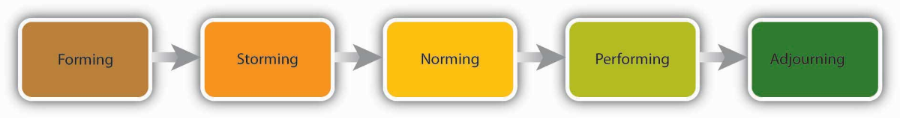Stages of the Group Development Model​

Forming
In the Forming stage, the group comes together for the first time. The members may already know each other or they may be total strangers. In either case, there is a level of formality, some anxiety, and a degree of guardedness as group members are not sure what is going to happen next. “Will I be accepted? What will my role be? Who has the power here?” These are some of the questions participants think about during this stage of group formation. Because of the large amount of uncertainty, members tend to be polite, conflict avoidant, and observant. They are trying to figure out the “rules of the game” without being too vulnerable. At this point, they may also be quite excited and optimistic about the task, perhaps experiencing a level of pride at being chosen to join a particular group.
Group members are trying to achieve several goals at this stage, although this may not necessarily be done consciously. First, they are trying to get to know one another. Often this can be accomplished by finding some common ground. Members also begin to explore group boundaries to determine what will be considered acceptable behavior. “Can I interrupt? Can I leave when I feel like it?” This trial phase may also involve testing the appointed leader or seeing whether a leader emerges from the group. At this point, group members are also discovering how the group will work in terms of what needs to be done and who will be responsible for each task. This stage is often characterized by abstract discussions about issues to be addressed by the group; those who like to get moving can become impatient with this part of the process. This phase is usually short in duration, perhaps a meeting or two.

Storming
Once group members feel sufficiently safe and included, they tend to enter the Storming phase. Participants focus less on keeping their guard up as they shed social facades, becoming more authentic and more argumentative. Group members begin to explore their power and influence, and they often stake out their territory by differentiating themselves from the other group members rather than seeking common ground. Discussions can become heated as participants raise conflicting points of view and values, or disagree over how tasks should be done and who is assigned to them. It is not unusual for group members to become defensive, competitive, or jealous. They may take sides or begin to form cliques within the group. Questioning and resisting direction from the leader is also quite common. “Why should I have to do this? Who designed this project in the first place? What gives you the authority to tell me what to do?”
Although little seems to get accomplished at this stage, it actually serves an important purpose: group members are becoming more authentic as they express their deeper thoughts and feelings. What they are really exploring is “Can I truly be me, have power, and be accepted?” During this chaotic stage, a great deal of creative energy that was previously buried is released and available for use, but it takes skill to move the group from Storming to Norming. In many cases, the group gets stuck in the Storming phase.
Once group members discover that they can be authentic and that the group is capable of handling differences without dissolving, they are ready to enter the next stage, Norming.

Norming
“We survived!” is the common sentiment as this stage. Group members often feel elated at this point, and they are much more committed to each other and the group’s goal. Feeling energized by knowing they can handle the “tough stuff,” group members are now ready to get to work. Finding themselves more cohesive and cooperative, participants find it easy to establish their own ground rules (or norms) and define their operating procedures and goals. The group tends to make big decisions, while subgroups or individuals handle the smaller decisions. It is hoped at this point the group members are more open and respectful toward each other and willing to ask one another for both help and feedback. They may even begin to form friendships and share more personal information.
At this point, the leader should become more of a facilitator by stepping back and letting the group assume more responsibility for its goal. Since the group’s energy is running high, this is an ideal time to host a social or team-building event.

Performing
Galvanized by a sense of shared vision and a feeling of unity, the group is ready to go into high gear. Members are more interdependent, individuality and differences are respected, and group members feel themselves to be part of a greater entity. At the Performing stage, participants are not only getting the work done, but they also pay greater attention to how they are doing it. They ask such questions as, “Do our operating procedures best support productivity and quality assurance? Do we have suitable means for addressing differences that arise so we can preempt destructive conflicts? Are we relating to and communicating with each other in ways that enhance group dynamics and help us achieve our goals? How can I further develop as a person to become more effective?” By now, the group has matured, becoming more competent, autonomous, and insightful.
Group leaders can finally move into coaching roles and help members grow in skill and leadership. These leadership shifts are essential for managers enacting the Leadership function to keep in mind. In fact, a manager who leads multiple teams may find it necessary to shift leadership styles not only over time but between teams at different stages.

Adjourning
Just as groups form, so do they end. For example, many groups or teams formed in a business context are project-oriented and therefore are temporary. Alternatively, a working group may dissolve because of an organizational restructuring. As with graduating from school or leaving home for the first time, these endings can be bittersweet, with group members feeling a combination of victory, grief, and insecurity about what is coming next. For those who like routine and bond closely with fellow group members, this transition can be particularly challenging. Group leaders and members alike should be sensitive to handling these endings respectfully and compassionately. An ideal way to close a group is to set aside time to debrief (“How did it all go? What did we learn?”), acknowledge one another, and celebrate a job well done.

